**Employee Management Service**

🔹**Project Objective:**

The goal of this project is to create an integration application using **TIBCO BusinessWorks 5.x** to automate HR processes based on employee data. The application will read employee details from a **.csv file** and perform various HR tasks, ensuring streamlined management and error handling throughout the process.

🔹**TIBCO products and tools used:**

TIBCO BusinessWorks 5.x, TIBCO Designer, TIBCO Administrator, MariaDB

🔹**Features:**

Automated employee management: Based on the input CSV file, the application automates key HR processes:

- Hire Employees: Efficiently onboard new employees.

- Promote Employees: Manage employee promotions based on predefined criteria.

- Employee separation: Handle employee separation as per the instructions.

- Log Details: Log all actions into the database for record-keeping and auditing.

🔹**Activities Used:**

- Parse palette: Parse Data

- General Activity Palette: Write to log, Mapper, Timer, Catch, Generate error, Assign

- JDBC Palette: JDBC query, JDBC update

- XML Activities: Render XML

- File Palette: Read file, Write file

-Java: Java code

**🔹Efficient Deployment and Management:**

Utilized TIBCO Administrator for effective deployment, management, and monitoring of the application, ensuring smooth and efficient operations.

**🔹 Enhanced Monitoring & Troubleshooting**:

Handled errors and exceptions using Catch and Generate error activities, and dumped logs into the database. Specific error scenarios include:

- If an employee doesn't exist.

- If the file doesn't exist.

- If the file is empty.

The application throws exceptions and logs error details into the database for quick resolution.

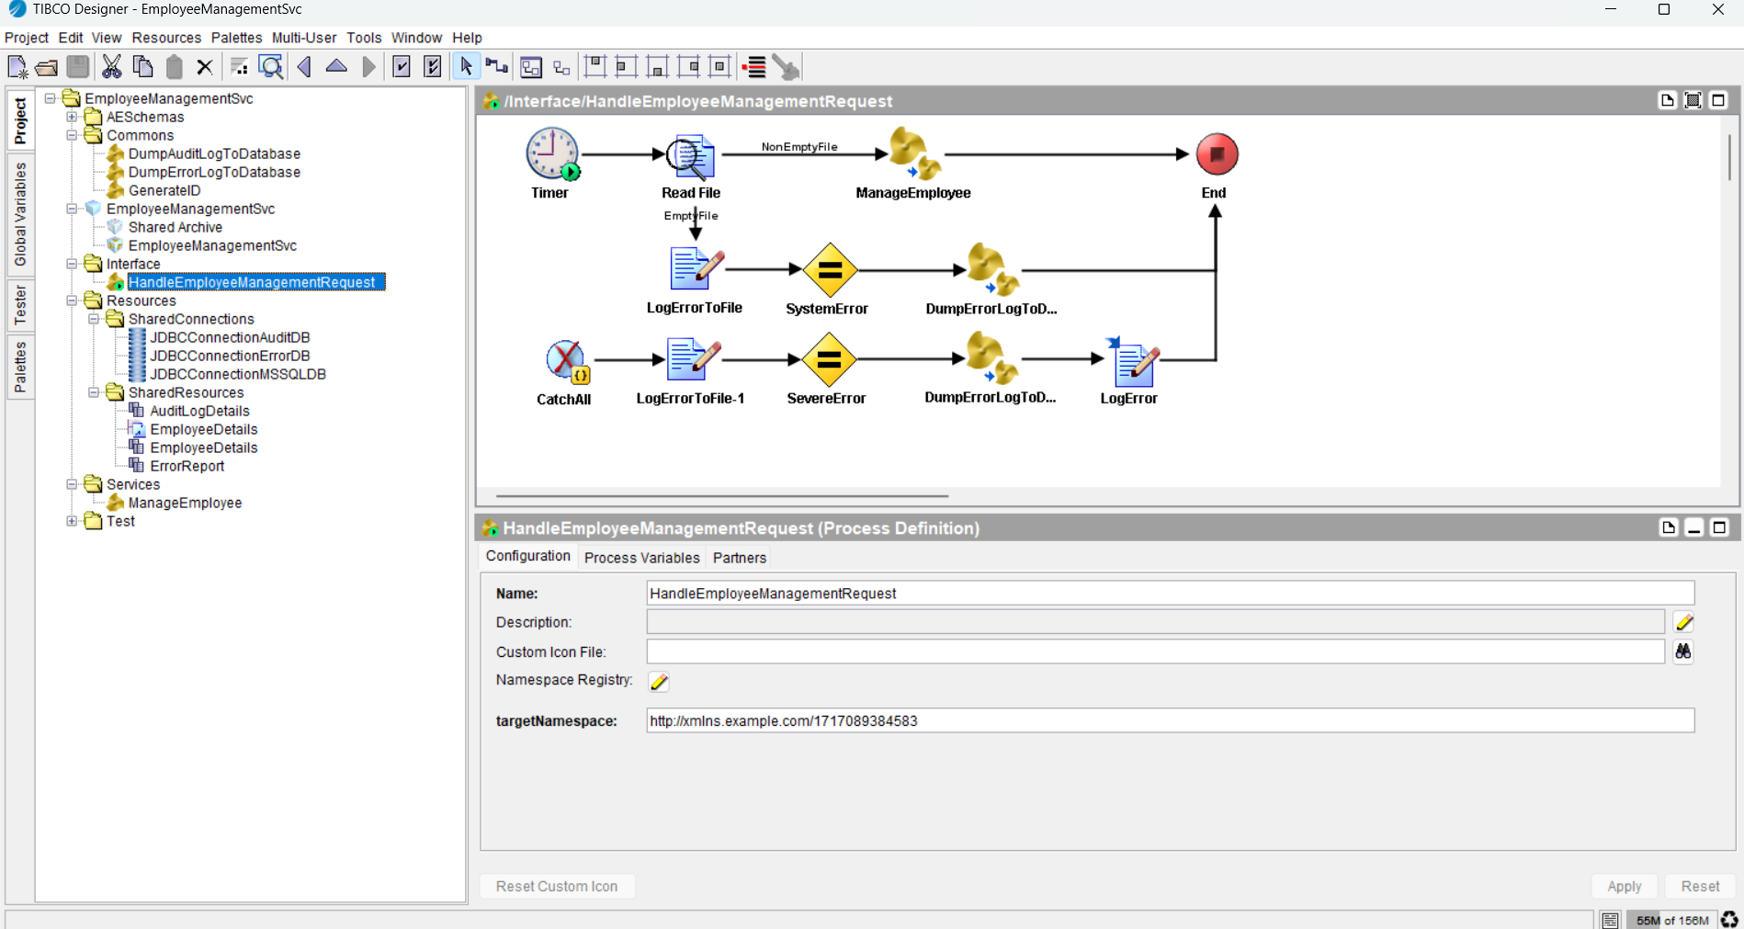

I have published the BW code on GitHub repository:

https://github.com/angrygabbar/EmployeeManagementsvc

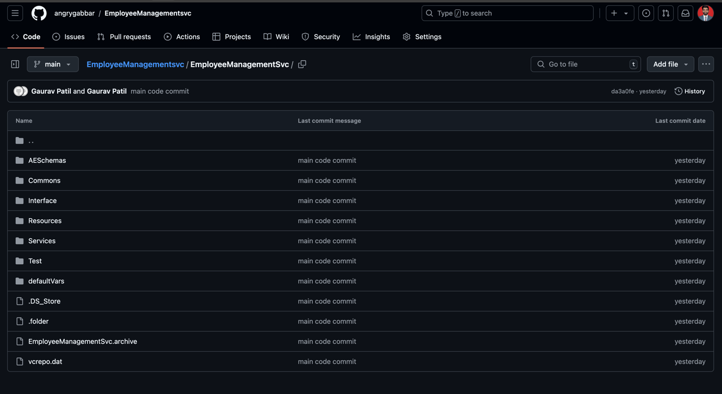

**Project implementation:**

**Scenario 1:** Hire Employees

**A)Success scenario: Employee doesn’t exist**

Read an input file:

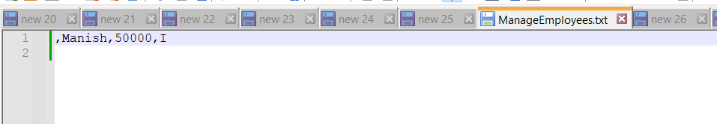

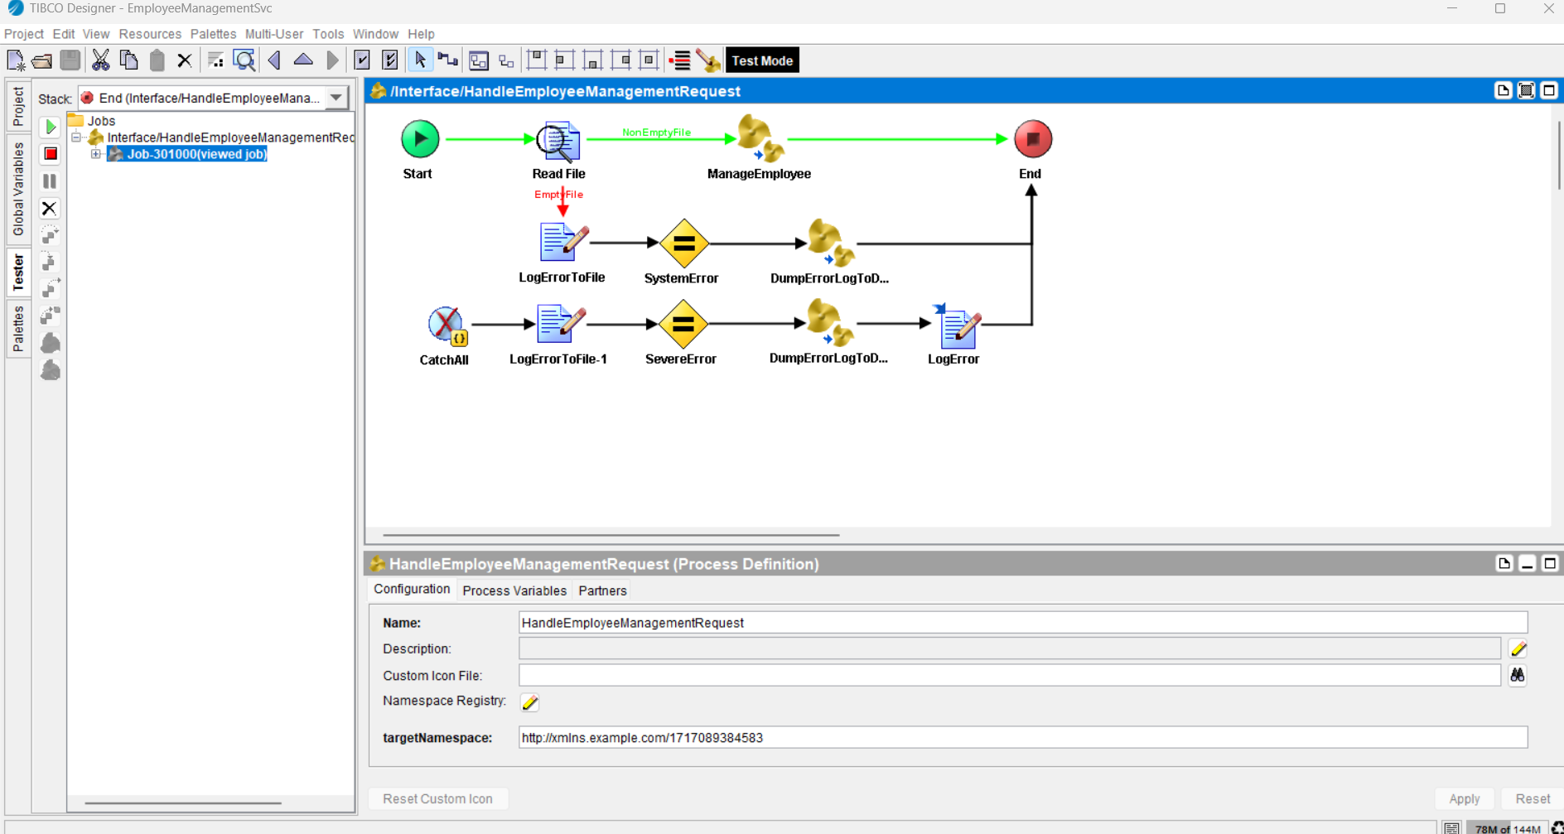

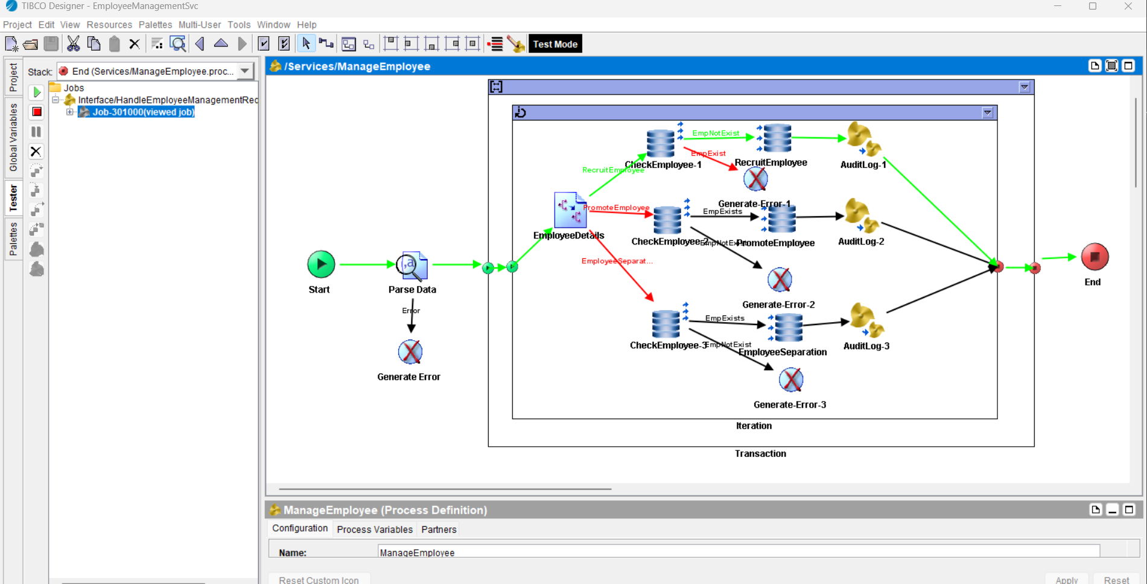

Employee details are added successfully into the database table: Employee

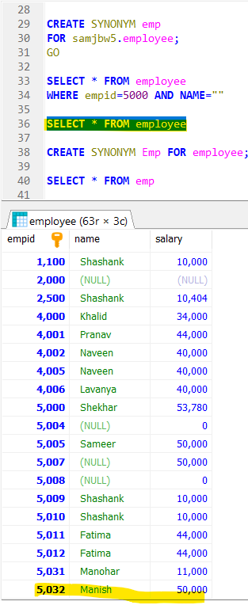

Input details are dumped into the database for audit purpose.

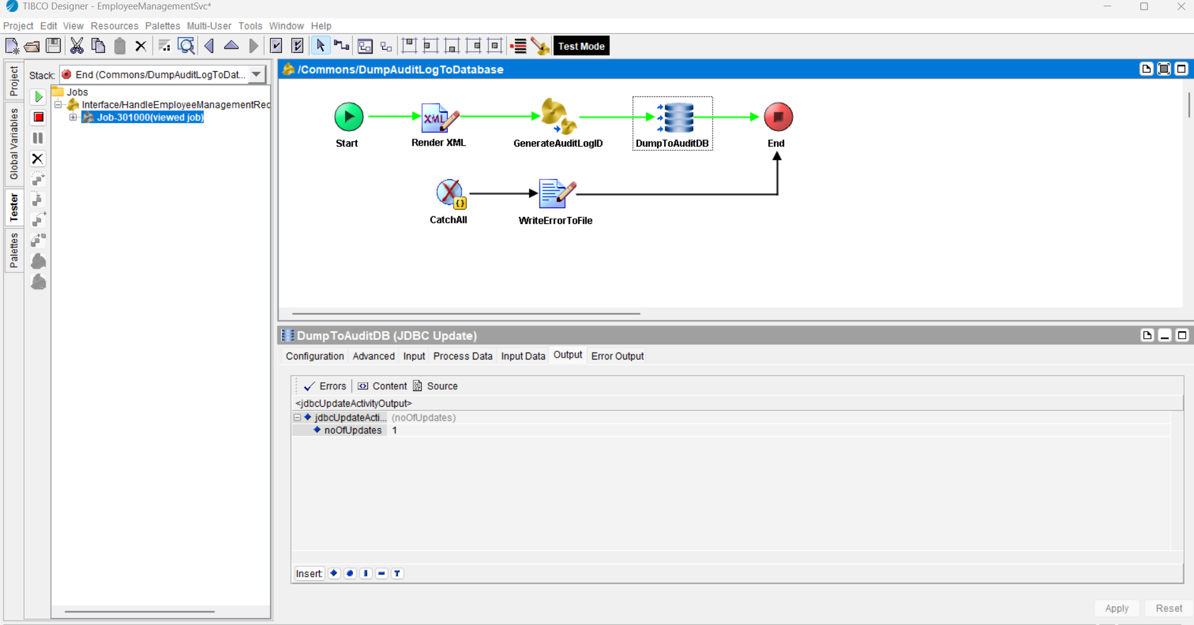

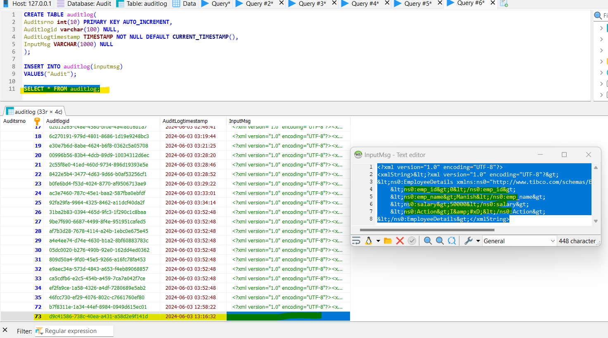

**B)Error scenario: Employee already exists**

Read an input file with an employee id already exists:

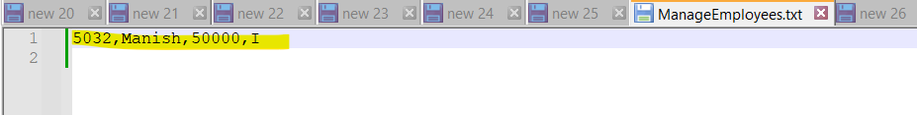

It identified that that exployee already exist, hence it catched the exception and error logs are dumped into the database.

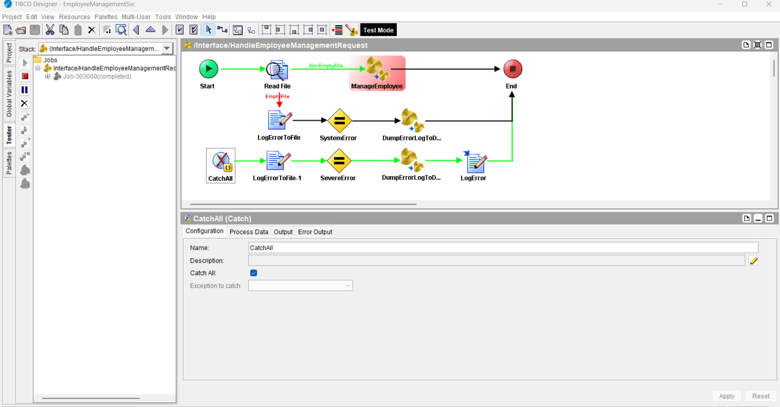

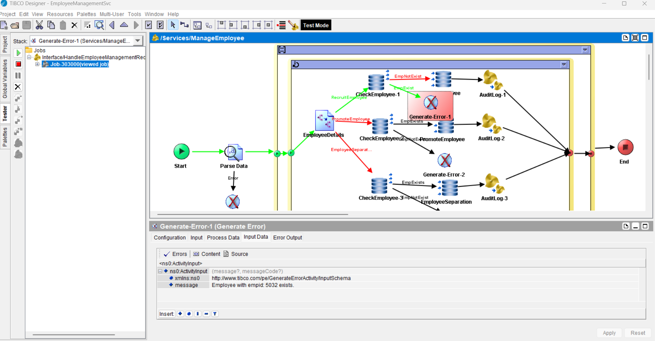

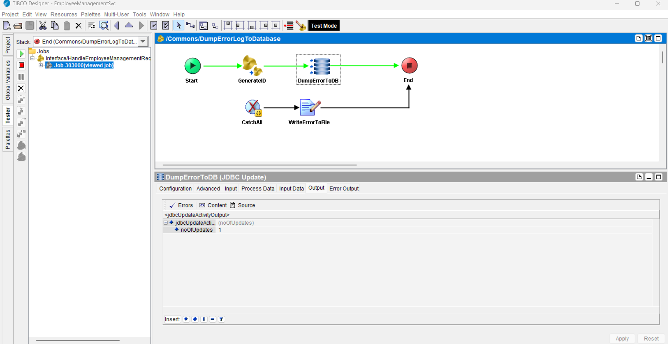

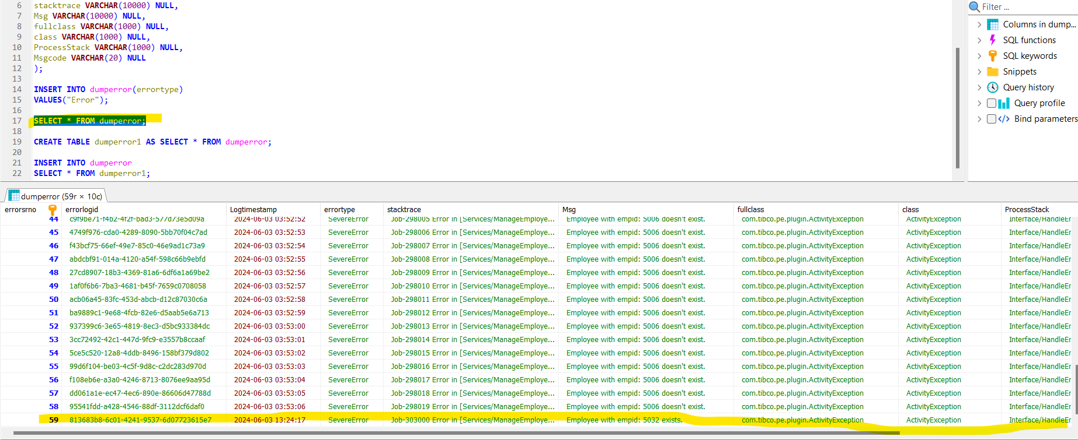

**Scenario 2:** Promote Employees

**A)Success scenario: Employee exist**

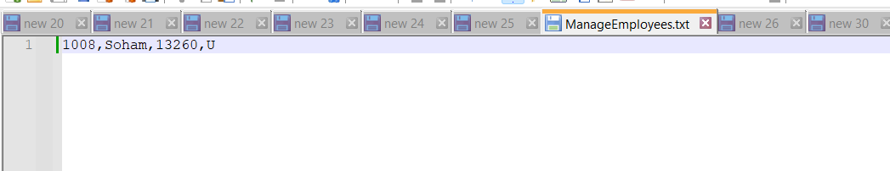

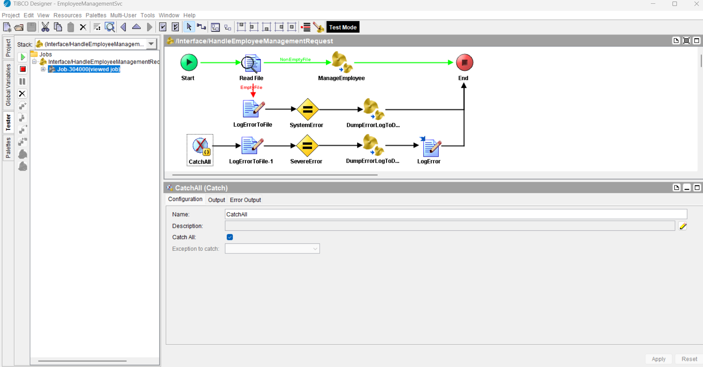

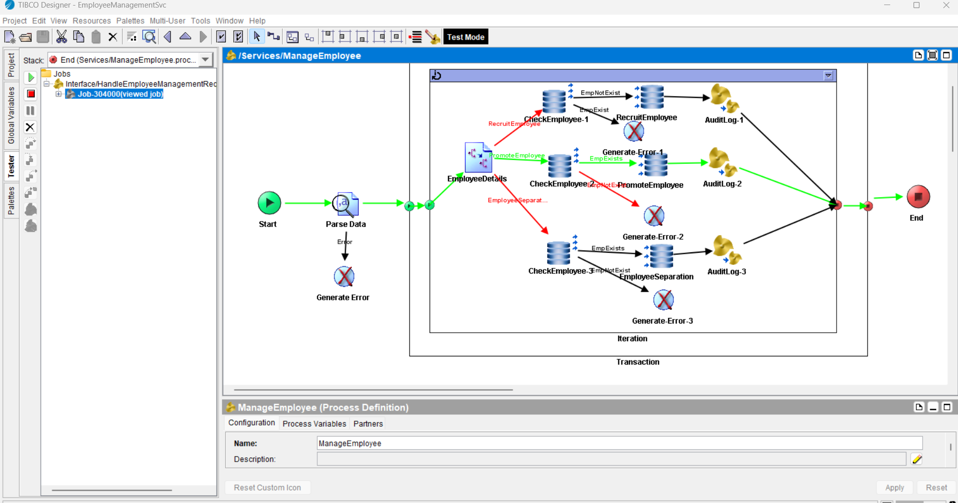

Employee salary has been incremented as per the logic.

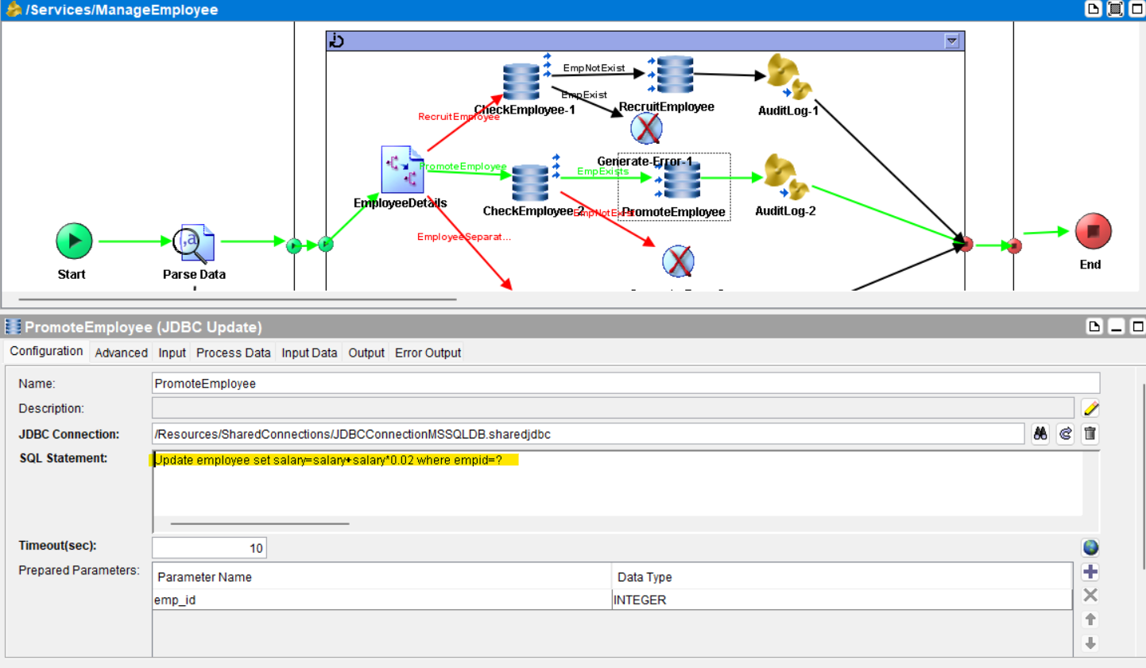

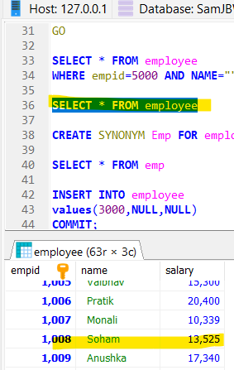

Input details are logged into the database for audit purpose.

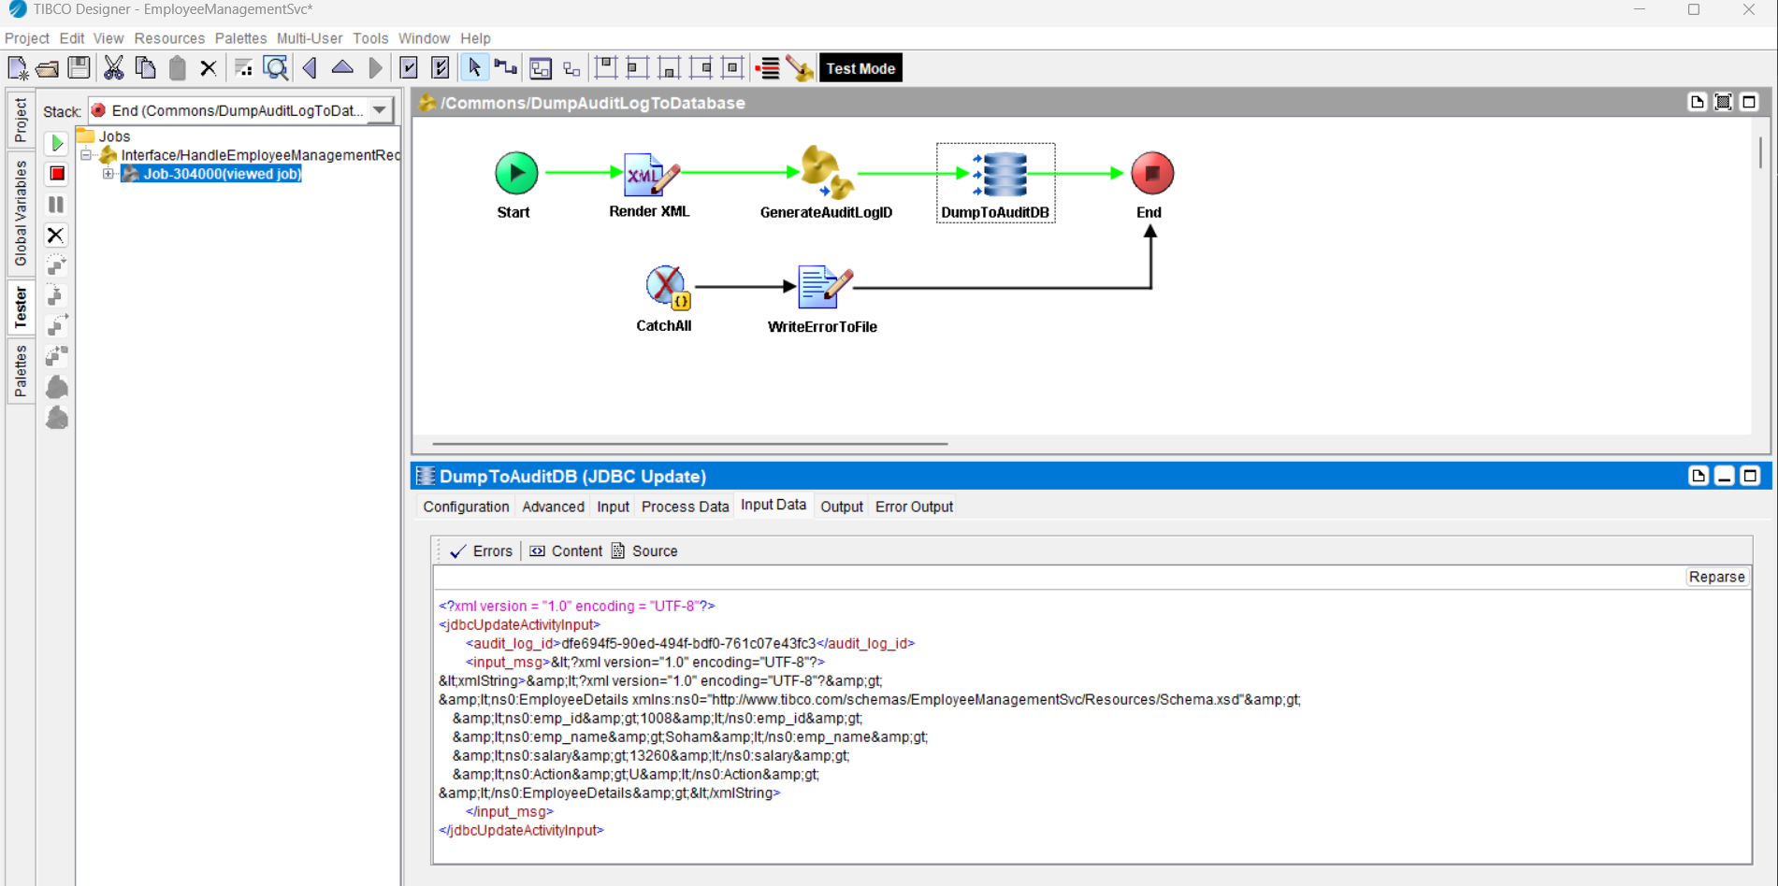

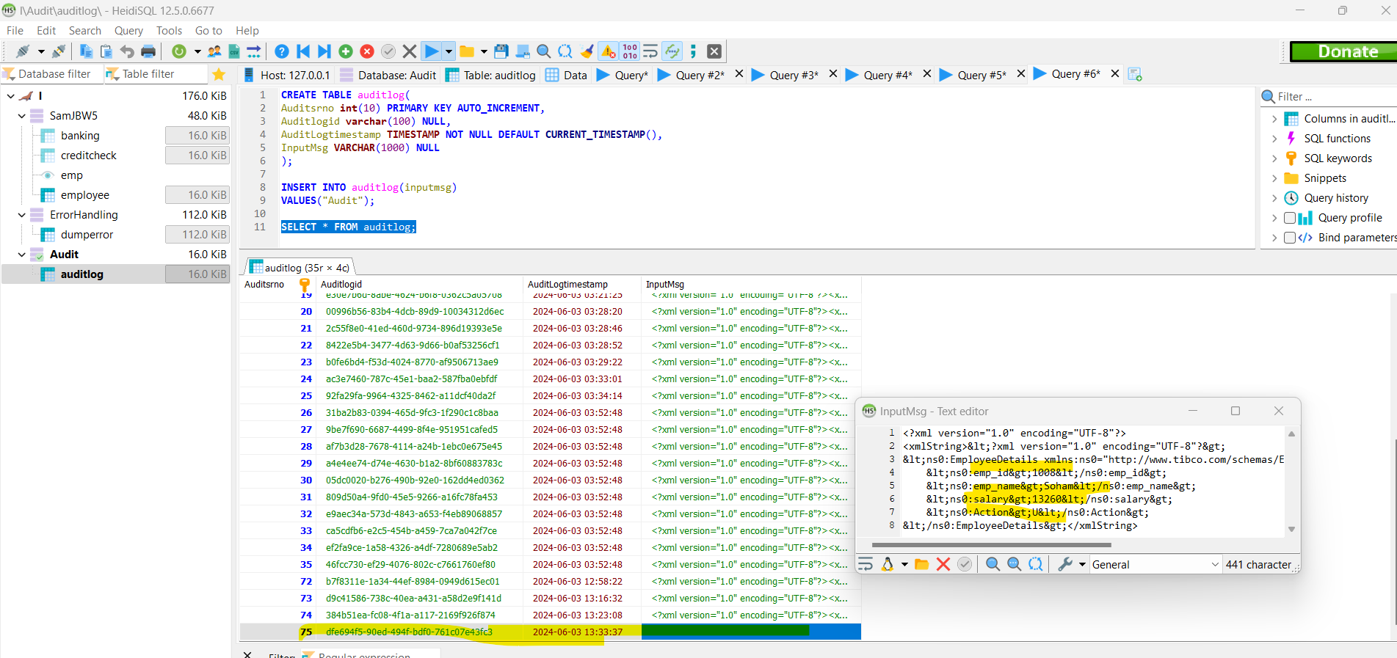

**B)Error scenario: Employee doesn’t exist**

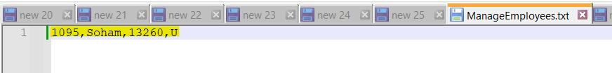

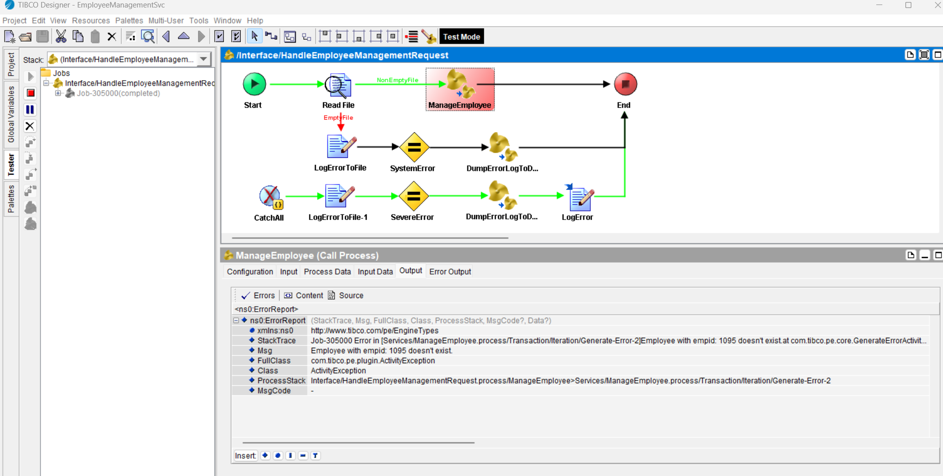

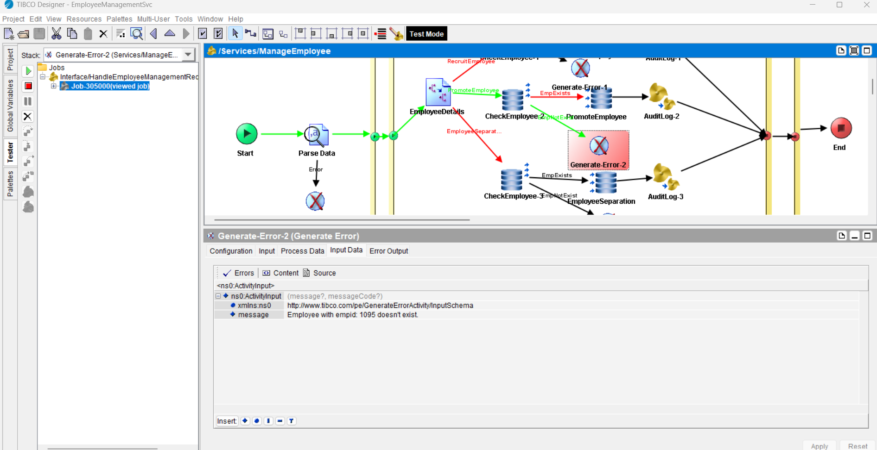

Error details are logged into the database:

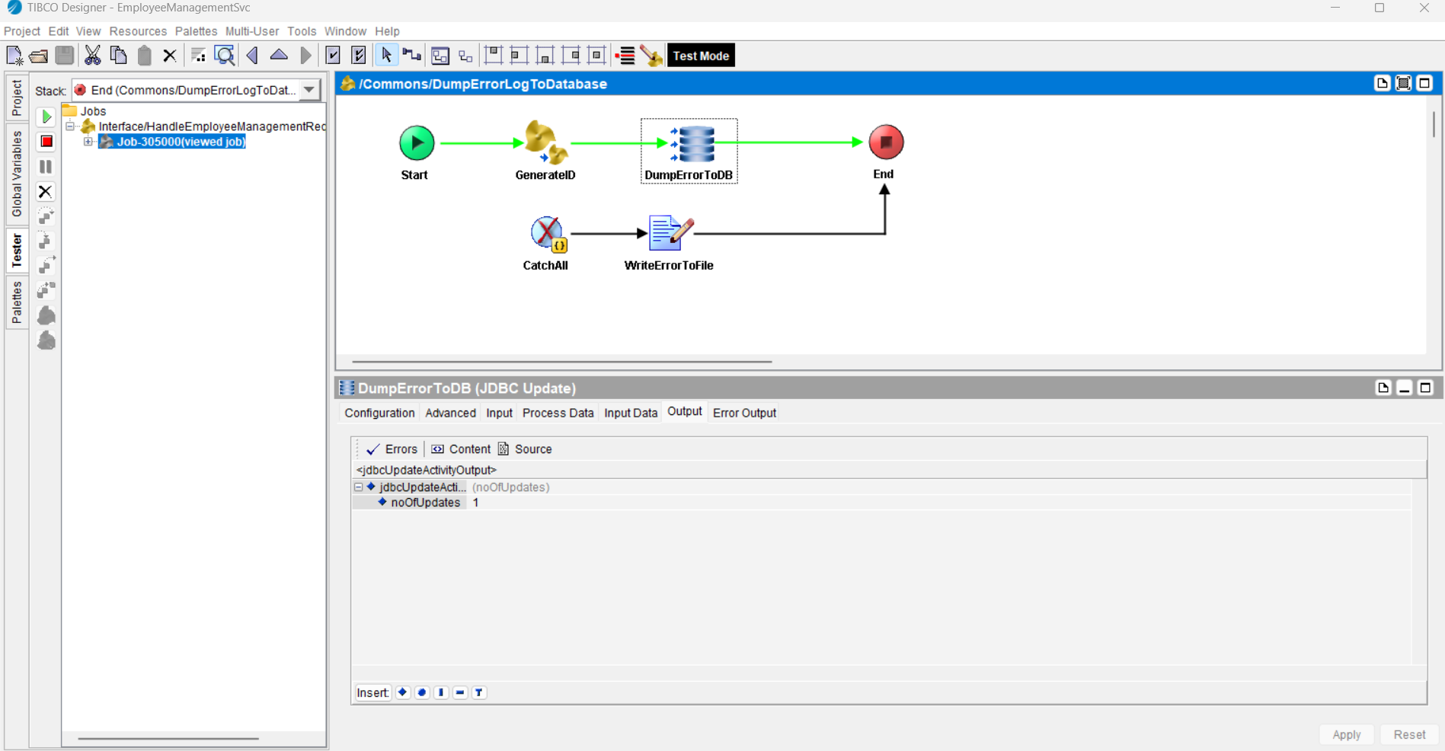

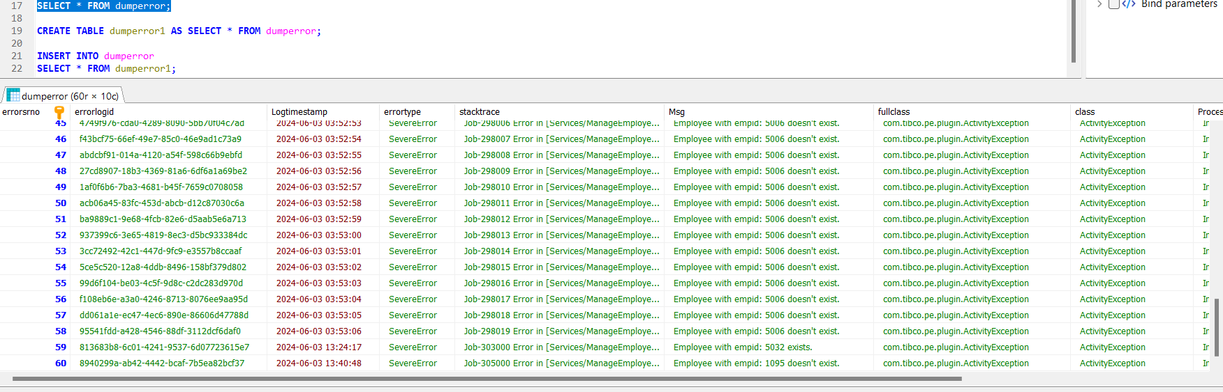

**Scenario 3:** Employee separation

**A)Success scenario: Employee exists**

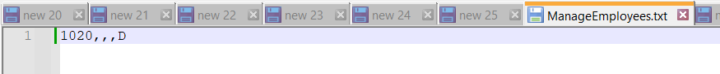

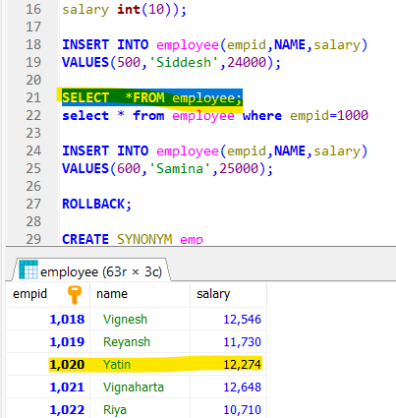

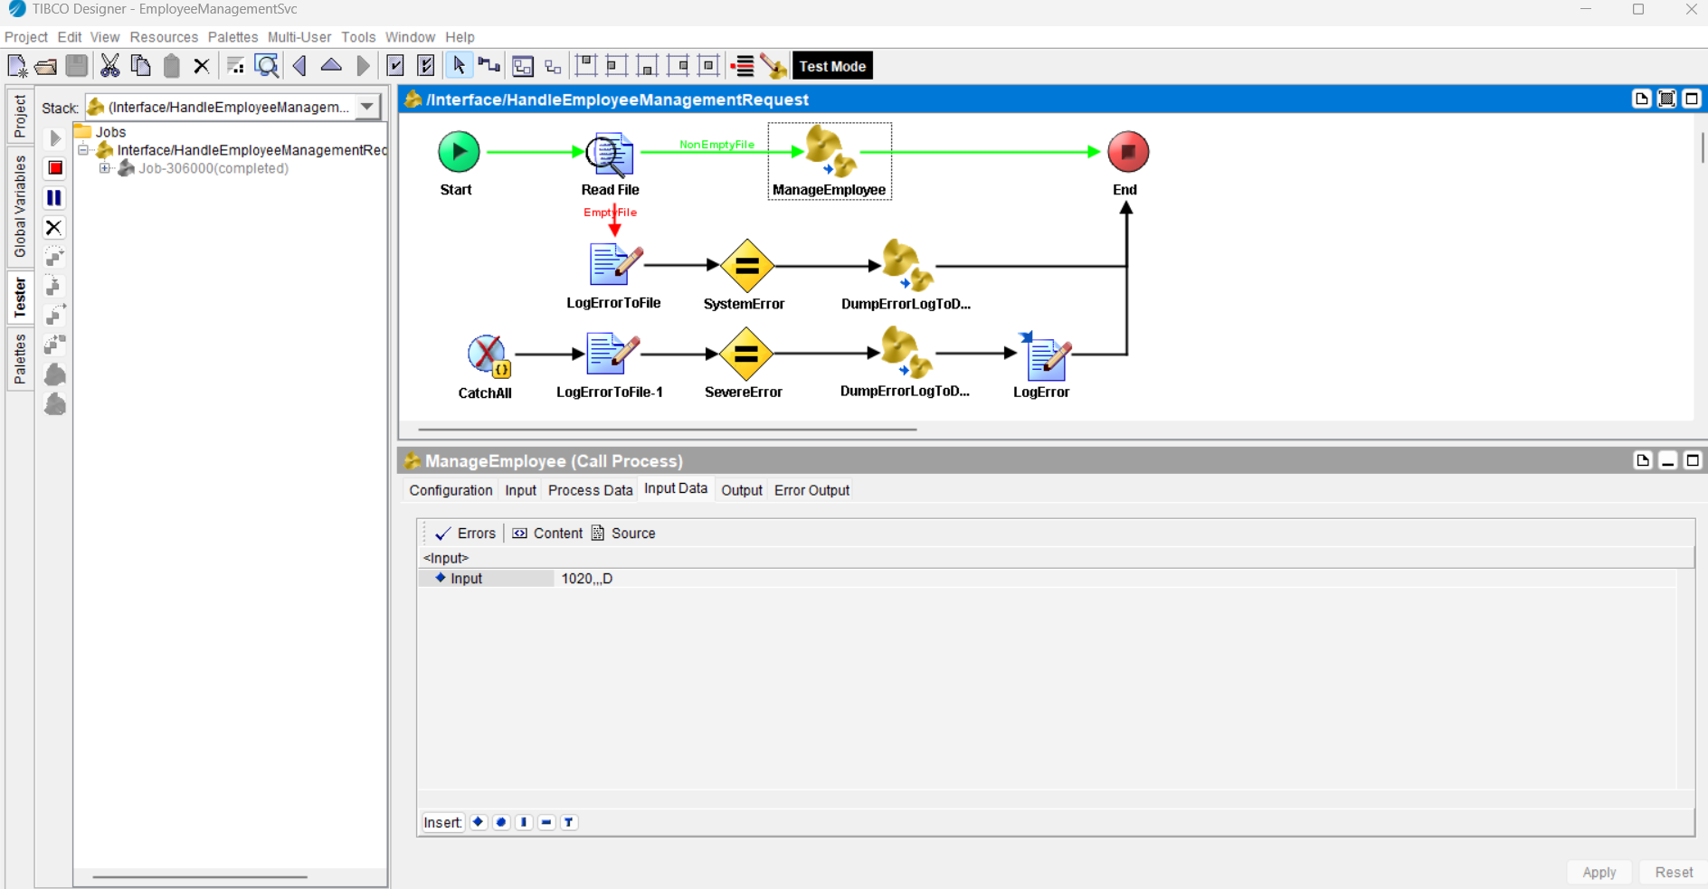

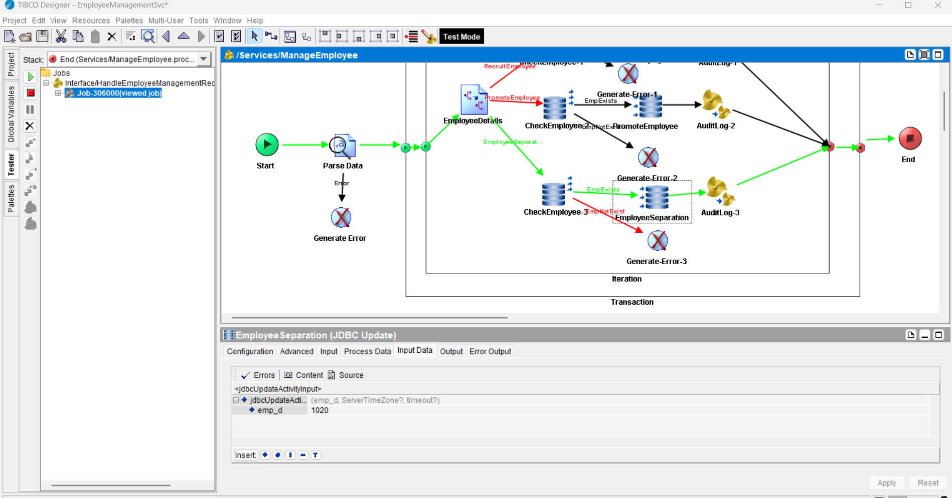

**Employee details are deleted from the database successfully.**

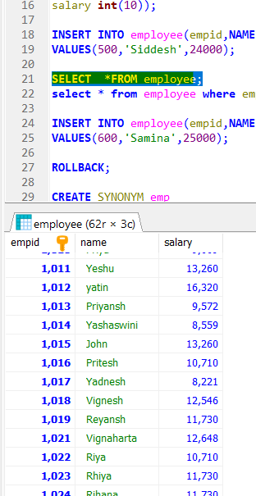

**Input details are logged into the database for audit purpose.**

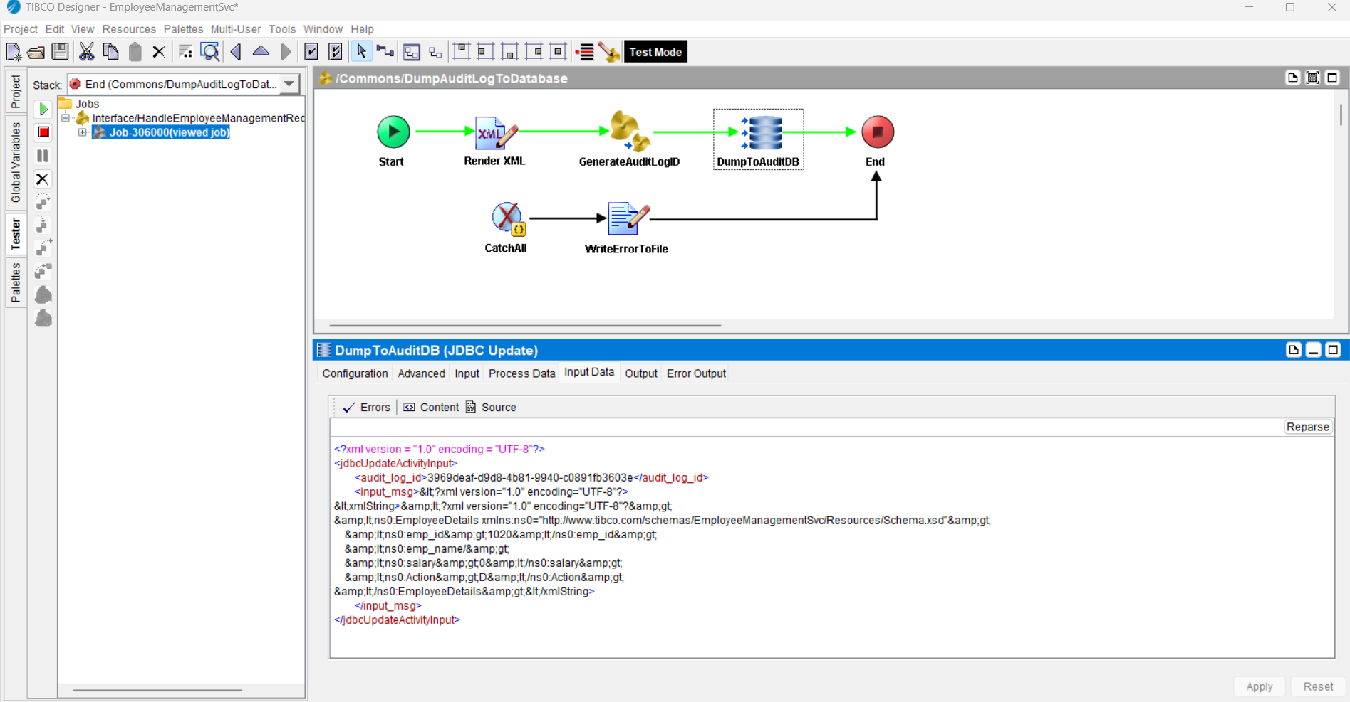

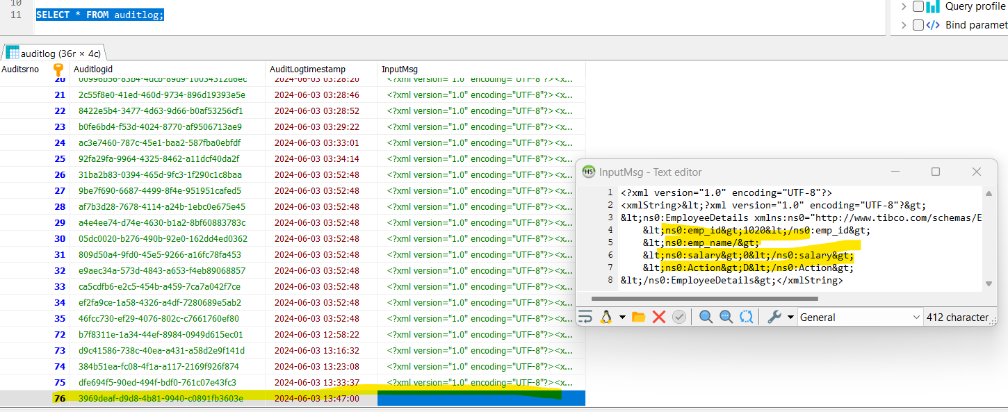

**B)Error scenario: Employee doesn’t exist**

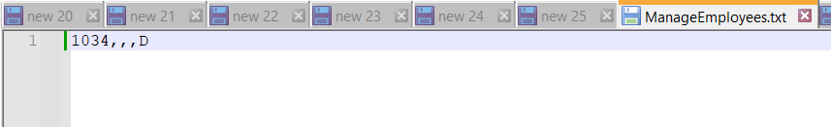

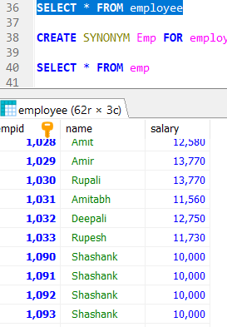

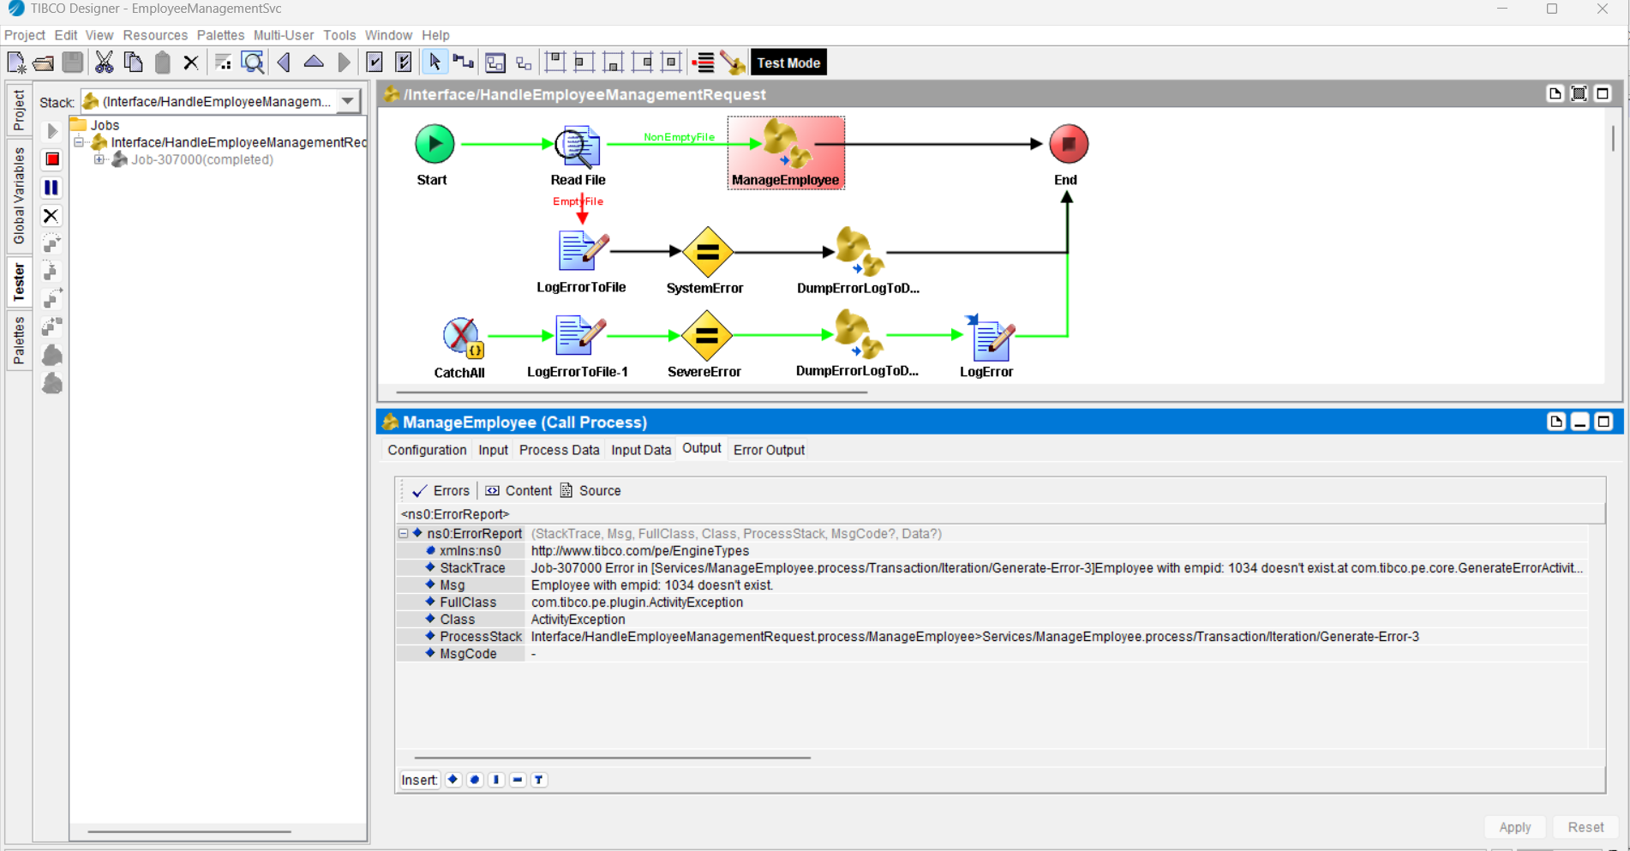

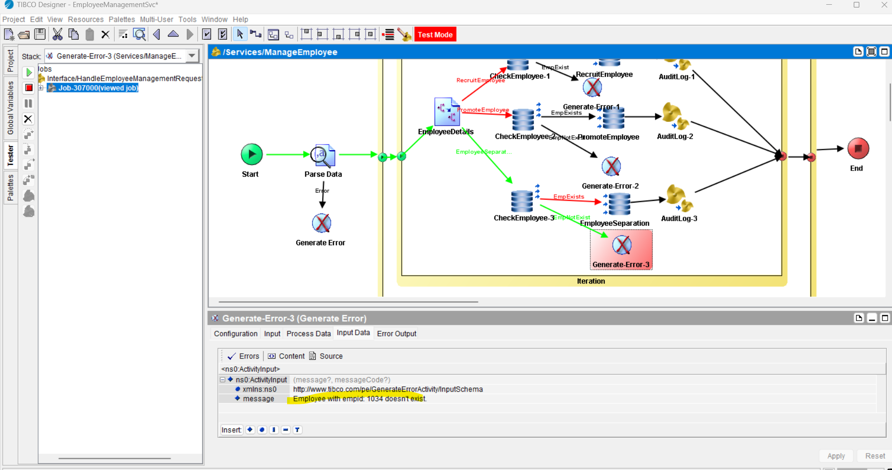

Error details are logged into the database:

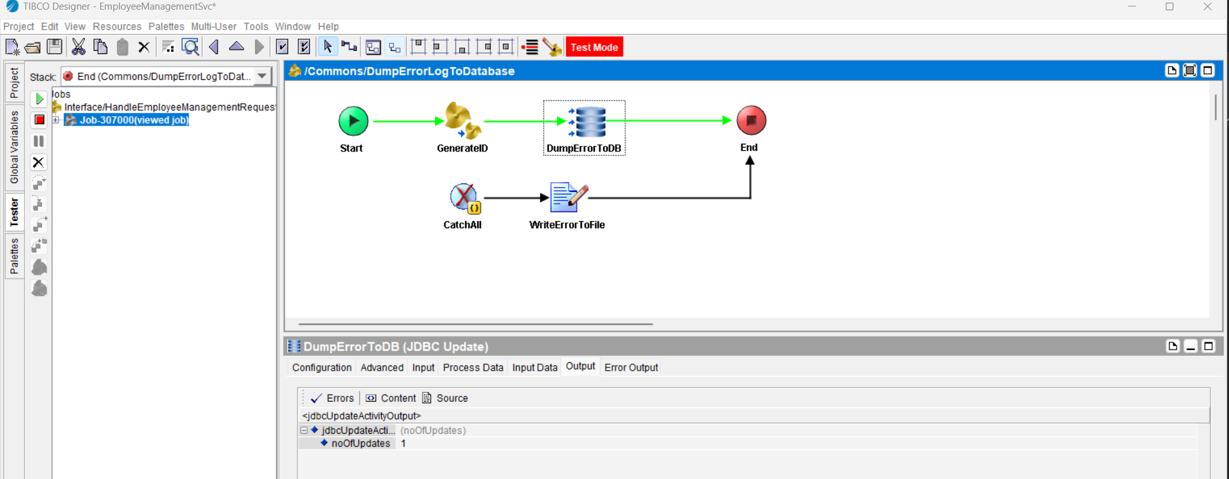

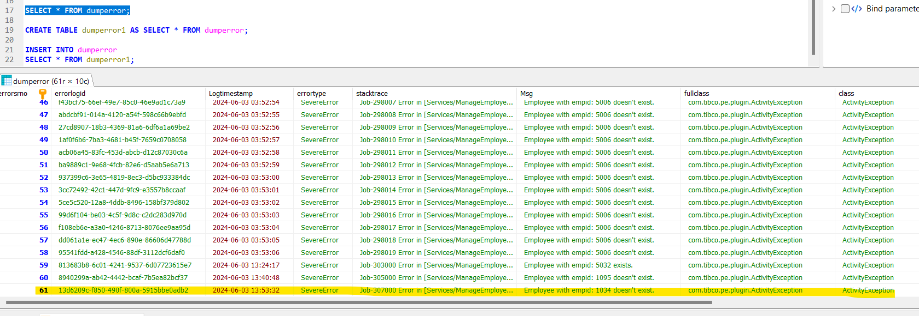

**Deployment to Tibco Administrator:**

**Created an .ear file.**

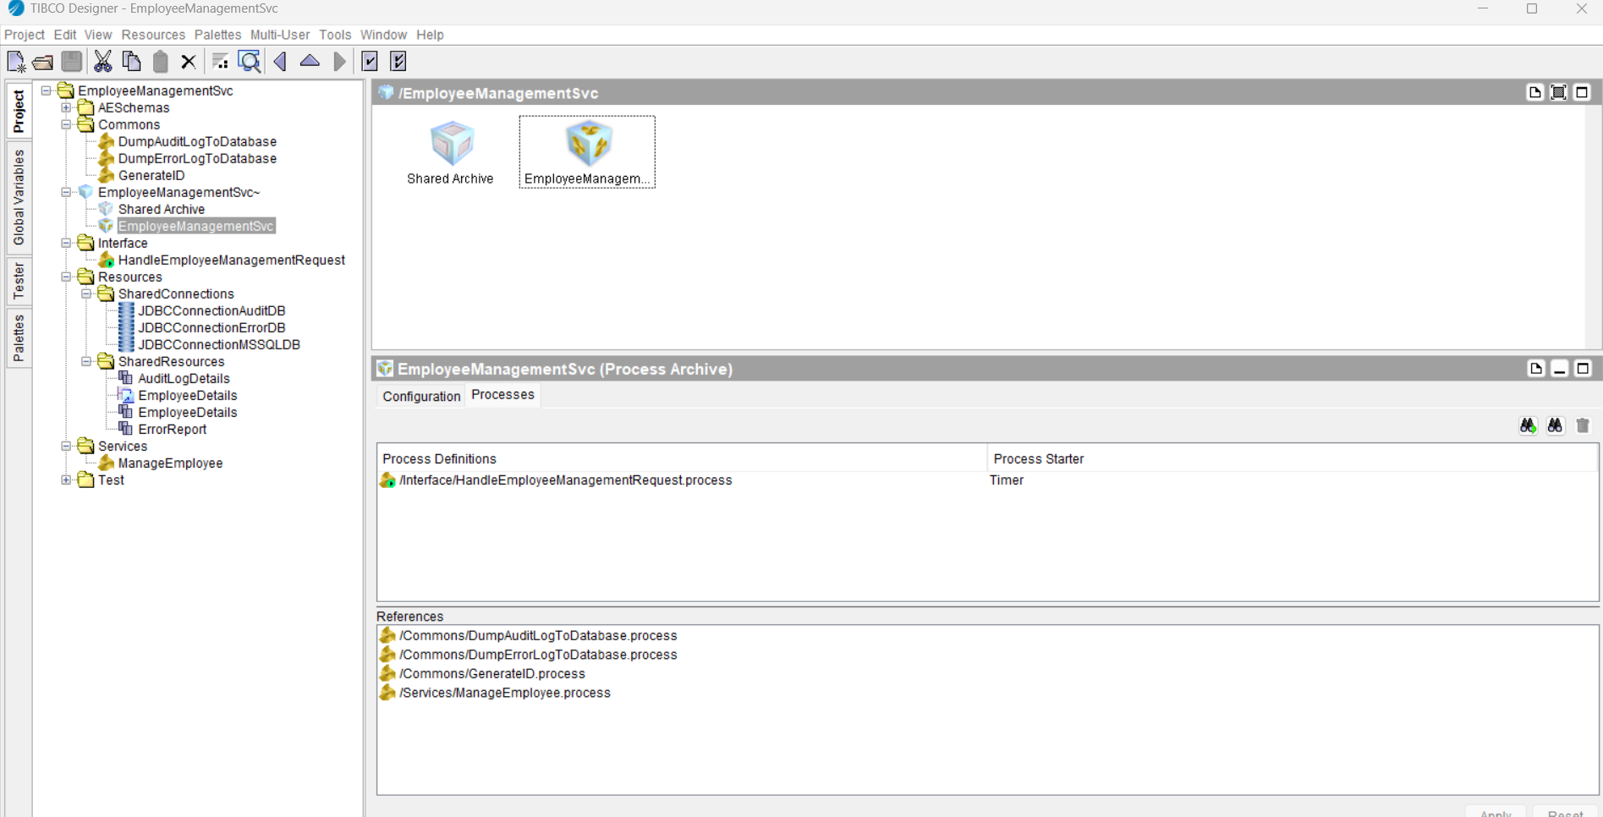

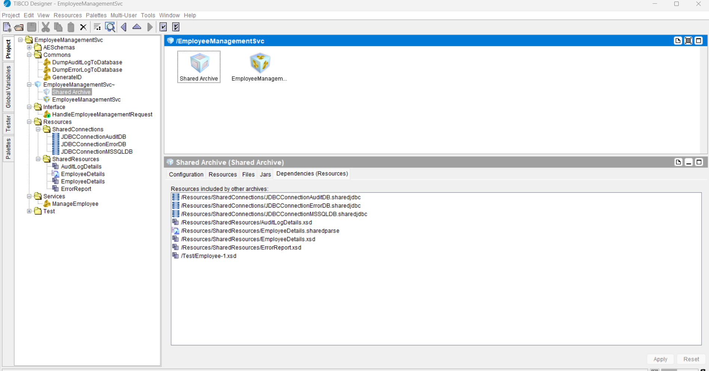

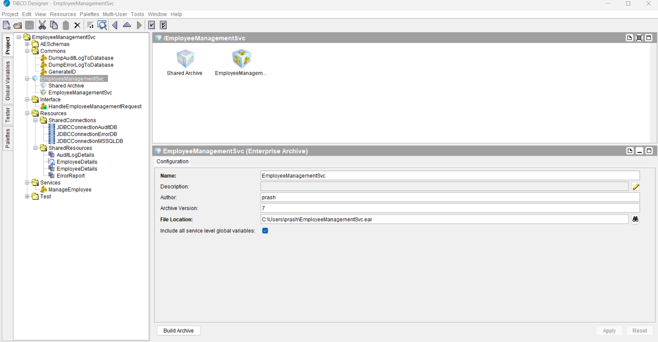

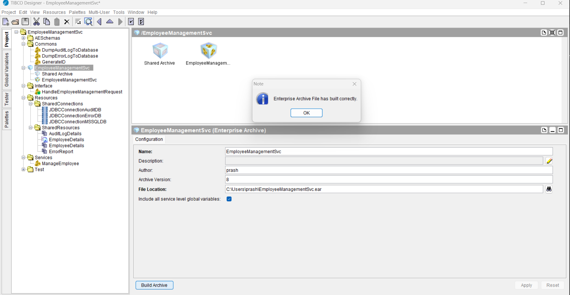

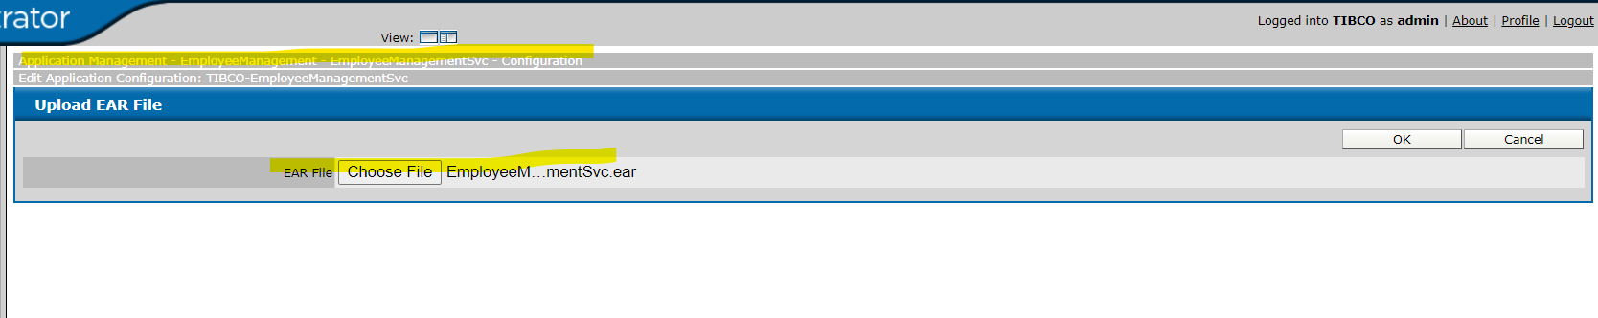

Application has been successfully deployed on TIBCO Administrator.

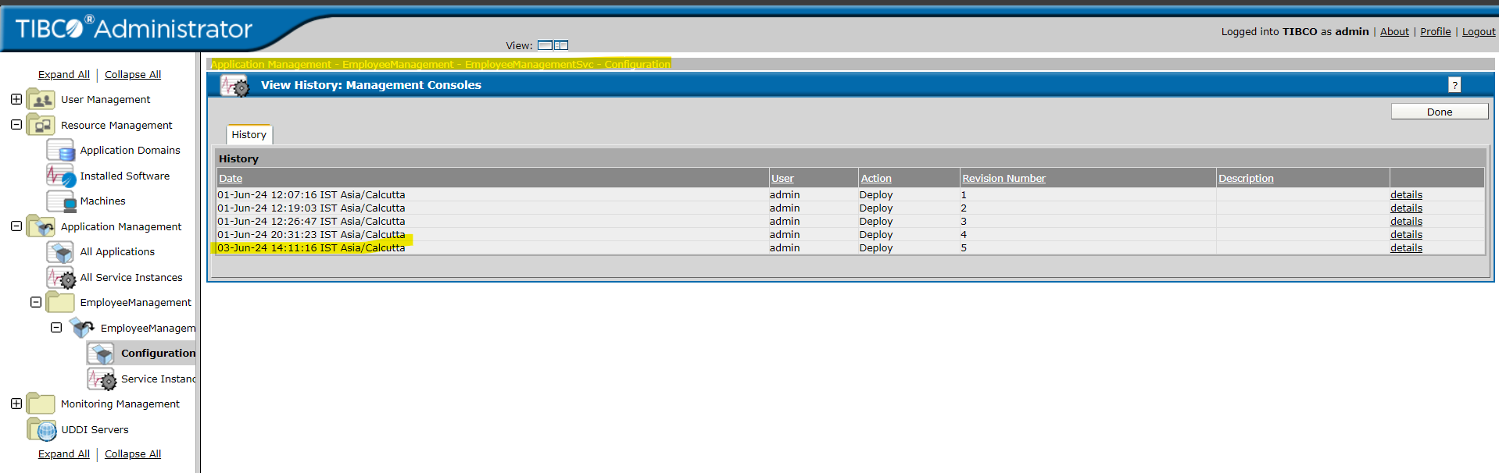

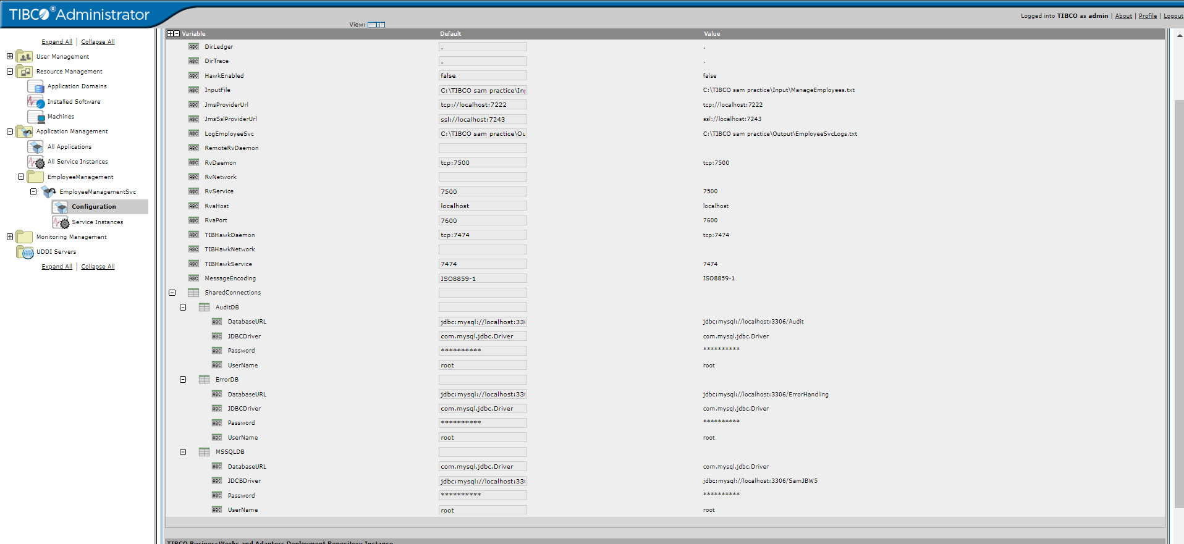

Check process stats:

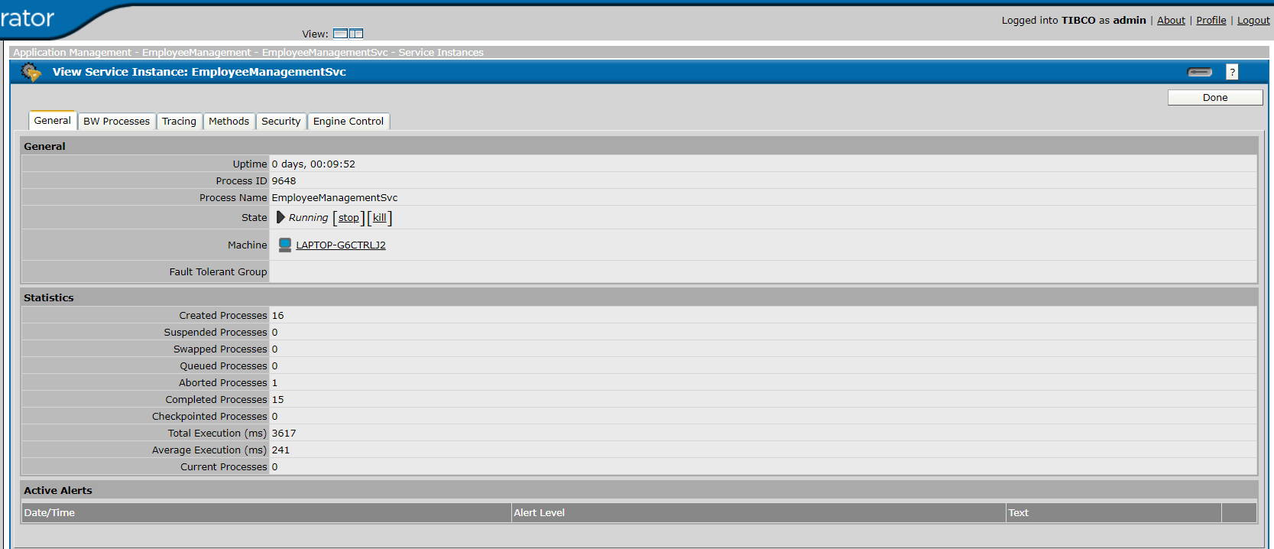

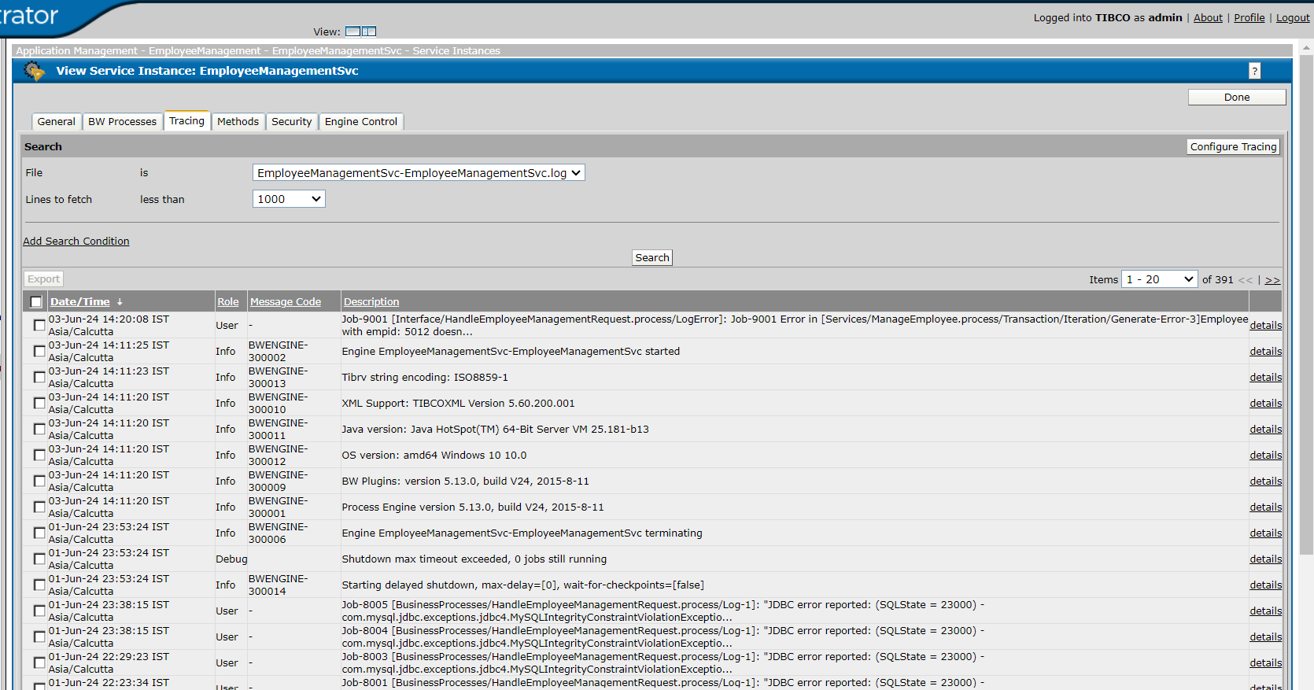

Check process stats for monitoring of the application, ensuring smooth and efficient operations.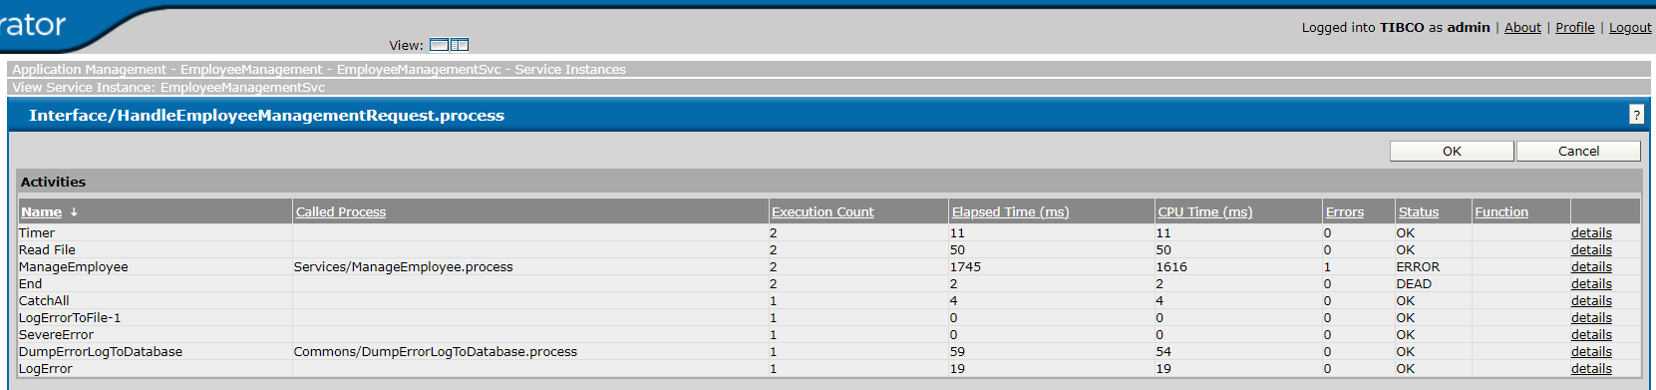

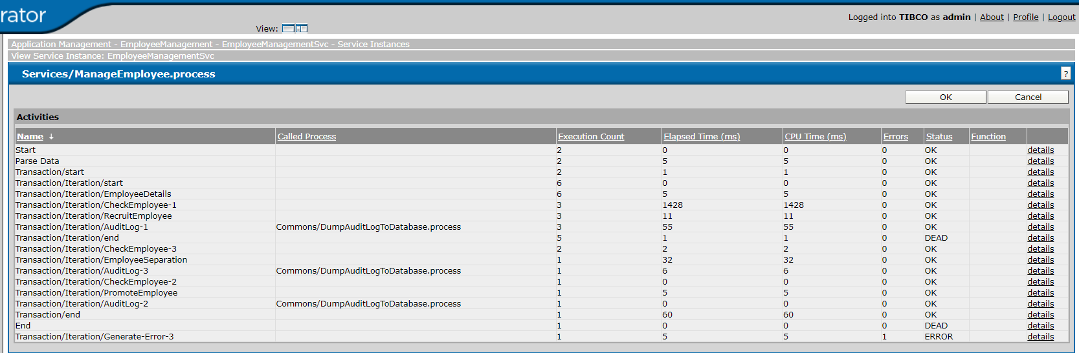

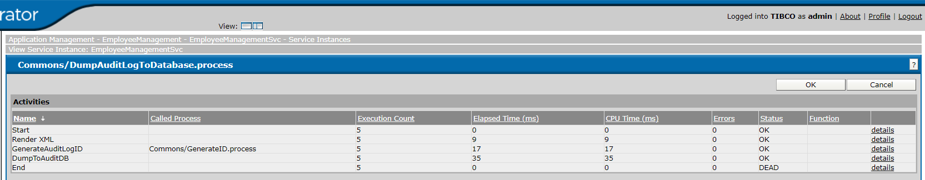

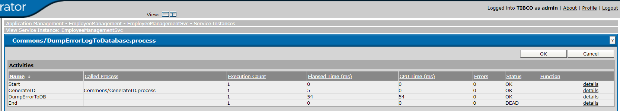

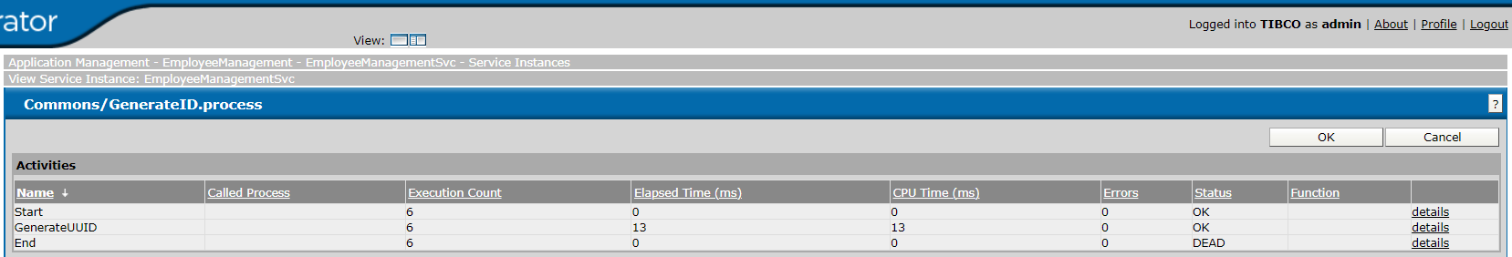

**Thank you…**